Lab for chapter 5
The notes and answers for the lab in chapter 5 are included in this document.

Complete the Try it Now sections

Account Expiry
Force account expiry
Set-ADAccountExpiration -Identity dgreen -DateTime (get-date).AddDays(-5)

Reset Expiry date – 30 days from now
Get-ADUser -Identity dgreen | Set-ADAccountExpiration -DateTime (Get-Date).AddDays(30)

Reset Expiry date – specific date
Get-ADUser -Identity dgreen | Set-ADAccountExpiration -DateTime ([datetime]'06/14/2014')

Note: .NET expects date as month/day/year. Could do this to be culture independent
$date = Get-Date -Day 14 -Month 6 -Year 2014 -Hour 0 -Minute 0 -Second 0
Get-ADUser -Identity dgreen | Set-ADAccountExpiration –DateTime $date

Clear expiry date i.e. never expires
Get-ADUser -Identity dgreen | Clear-ADAccountExpiration

Account lockout
View the default domain group policy
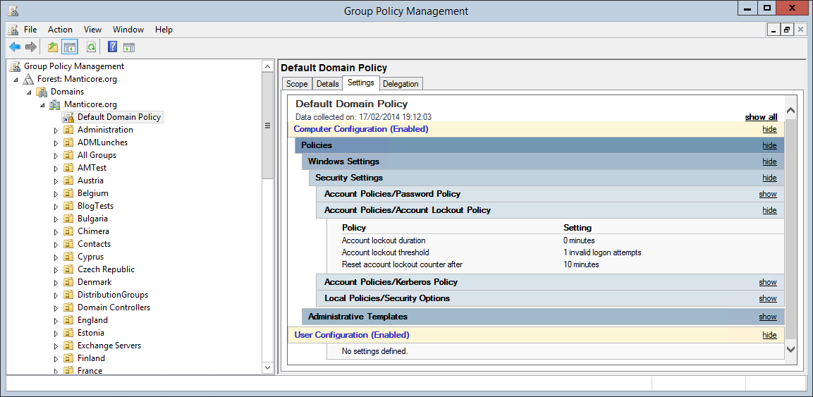
Alternatively use
Get-ADDefaultDomainPasswordPolicy
To view the default lockout policy

Discover and unlock account
Search-ADAccount -LockedOut
Unlock-ADAccount -Identity dgreen

Disable account
Disable-ADAccount -Identity dgreen
Enable-ADAccount -Identity dgreen

